Event Management Plan | 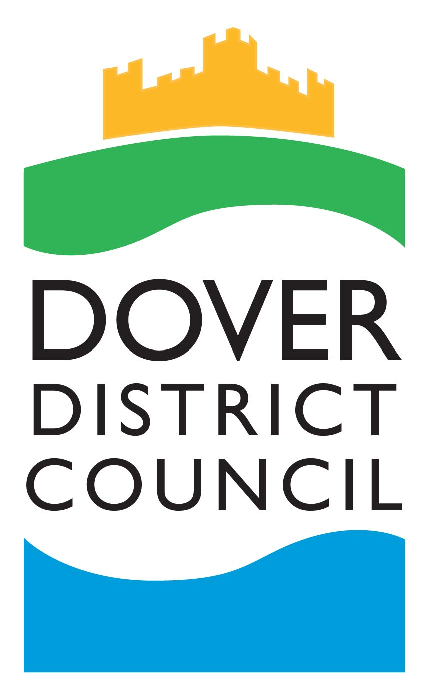

As an Event Organiser you are responsible for:

- Informing Dover District Council of your event
- Seeking permission of the relevant land owner
- Submitting the relevant documentation to Dover District Council in a timely manner to ensure it can be reviewed by the Events Safety Advisory Group
- Submitting road closure requests a minimum of 12 weeks before your event to satisfy KCC Highways Authority
- Ensuring the overall safety at your event as far as reasonably practicable
- Ensuring that health and safety arrangements are in place to control risks
- Ensuring the competence of staff at your event to undertake their roles safely
- Checking all insurance documents, risk assessments and methods of work for contractors, stall holders, caterers etc (these documents may also be requested by Dover District Council)
- The Health, Safety and Welfare of all members of staff, contractors and members of the public attending your event
- Informing the Performing Rights Society if you have live music at your event

Disclaimer: This template is a guide only. It does not necessarily include all the information that may be relevant to your event. Dover District Council is not responsible for any lack of information not submitted with this application.

Privacy Statement
Your personal information is required for administration purposes. Dover District Council is committed to protecting your privacy and fulfilling its obligations under UK data protection laws. Dover District Council may use this data in order to inform you of its activities and/or improve its services in relation to the subject matter only, but will not sell, rent, distribute or otherwise make your data commercially available to any third party, unless it is required to by a court order or to comply with other legal requirements.

What happens to my event information?
Your event notification form, event management plan, site plan, risk assessment and public liability certificate will be sent to the Events Safety Advisory Group (ESAG) for review. The ESAG consists of representatives from various departments at Dover District Council, Kent Fire and Rescue, KCC Highways, Kent Police and other emergency services. Your information will not be passed on to any other party without your prior consent.

Contents
1. Event Overview
2. Site Management
3. Incident Management
4. Traffic Management Plan
5. Event Safety Measures (Covid-19)

Please type your answers into the white boxes
Please refer to our Events Toolkit when completing this document

Event Organiser Details

Event Organiser Name

Organisation

Contact Telephone Number

Email Address

Name of Event

Location of Event

Date of Event

Contact Telephone Number on day of the event
(if different to above)

1. Event Overview

1.1 Event Overview

Please provide a description of your event

Please provide the following information about your event

Event start time

Event end time

1.2 Event Itinerary

Please provide timings of your event including set up and break down timings

Date / Time | Action

1.3 Programme of Events

Please provide your programme of activities and the timings for the day, including any performances (e.g. the start and finish times of any musical performances)

Time | Activity

1.4 Event Management

Roles and Responsibilities on Event Day (s)

Please provide a brief description of the roles of event staff and their main responsibilities.
There may be other roles that are not listed here that are applicable to your event.

Please note: the role of stewards is covered in section 2.13 so there is no need to complete the role of stewards in this section

Role | Responsibilities
Event Organiser
Event Manager
Site Manager
Health & Safety Officer
Arena/stage Manager
Steward Coordinator
Press and PR coordinator
Other

1.5 Crowd Management

Please provide details on how you will manage the crowd at your event

Please note: the role of stewards is covered in section 2.13 so there is no need to complete the role of stewards in this section

Is your event ticketed? If yes, what arrangements are in place for this?
How will you manage capacity at your event?
How will you manage the access and egress of the crowd?

1.6 Advertising

Please provide details of how you will advertise your event

How and where do you plan to advertise your event?
Will the media be in attendance and if so how will you handle them?
May we use the details supplied here for publicity purposes or to give to interested parties?
-  Yes  No

- If yes, which name and contact details can we release?

Would you like Dover District Council to use their Social Media to help you promote your event?
 Yes  No

2. Site Management

2.1 Contractor Management

Please provide details of any contractors that will be involved with your event
Please ensure that you check any safety documentation of contractors that you hire
Company | What are they providing/doing?

2.2 Traders

Please provide details of any traders/commercial traders and charity stalls that will be at your event
Please ensure that you check any safety documentation of traders
Name of Organisation | Concession Type

Sale of Alcohol
If you are selling alcohol at your event, please contact the licensing department as you will require a temporary events notice.
Please explain below how you will manage the sale of alcohol.
Catering Requirements (Food, drink, water)
For each catering supplier/food stall that you have attending your event, please provide the following information:
- Name of Business
- Address of Business
- Contact telephone number
- Name of local authority that they are registered with
- National food hygiene rating (if available)
2.3 Fencing and/or barriers

Please tell us if you plan to use any fencing and or barriers at your event including the type and their location
Please ensure that you check any safety documentation of contractors that you hire.

2.4 Electricity, Water, Gas Supply and Generators

Please tell us if you plan to use electricity, water, gas supply or other flammable liquids at your event. If so, please tell us where these will be sourced and the processes in place to manage these.

Please tell us if you plan to use any generators at your event. If so, please tell us where these will be sourced and the processes in place to manage these, including the storage and management of fuel and other flammable liquids.

Please ensure that you check any safety documentation of contractors that you hire.

2.5 Temporary Structures

Please list any temporary structures that you will have at your event and where they will be located e.g. gazebos, marquees, staging
Please ensure that you check any safety documentation of contractors that you hire.

2.6 Fire Safety

Please ensure that you have considered aspects related to fire safety at your event and provide detail here. Please ensure that you check any safety documentation of contractors that you hire.

2.7 Temporary Events Notice

IMPORTANT NOTE:

Licensable activities at your event such as the sale and supply of alcohol, the provision of late night refreshments to the public and regulated entertainment may require a temporary event notice (TEN). A temporary event notice is a notification to the licensing authority that an individual intends to carry on licensable activities for a period not exceeding 168 hours.

A temporary event notice application must be sent to the licensing authority and the police at least 10 working days in advance of a planned event. Please ensure that you have the necessary licences in place.

Please contact DDC licensing department for more information.

2.8 Musical Entertainment

Please tell us what entertainment you have arranged for your event i.e. Live music with amplification and how you manage noise disturbance and potential complaints.

Important notes:
- If you have live music you may require a Temporary Events Notice.
- It is your responsibility to inform the Performing Rights Society (www.prsformusic.com) if you are having live music at your event.
- Please ensure that you check any safety documentation of contractors that you hire.

2.9 Attractions

Please provide details of any attractions that will be at your event e.g. inflatable’s, funfair/children’s rides, fireworks

For these attractions make sure that you see a copy of the provider’s public liability insurance, risk assessment and method statement. For rides we will also need the name of each ride and their corresponding ADIPS number (Amusement Device Inspection Protection Scheme)

Please ensure that you check any safety documentation of contractors that you hire.
Name, address and telephone number of organisation | Attraction and ADIPS number if applicable

2.10 Medical and First Aid Cover

Please provide details of the medical provider and resources that you have arranged to be at your event including their location (i.e. number of first aiders, doctors, ambulances etc.)

2.11 Public Health and Welfare

Please provide details of the arrangements you have made for the following:

Toilet Facilities
Please provide details of sanitary arrangements, including: number, ratio of male to female and disabled, location, maintenance. Please bear in mind the opening times of public facilities.
There may be a charge if toilets are required outside normal opening times (check with Dover District Council). If inadequate provisions are available this can lead to a risk of a disruption to public order and safety.
Waste Disposal
Please provide details of the arrangements made for waste disposal, rubbish bins and litter collection at your event. As the event organiser you are responsible for arranging the disposal of waste. Any trade waste must be removed by a registered trade waste contractor.
Dover District Council is NOT responsible for arranging waste disposal at your event.

As the event organiser if you anticipate that any waste bins within the event area may get full please indicate the position of these bins on the event site plan. If extra ‘wheelie’ bins are required in those areas, please state below how many and where.
As the event organiser, are you happy to monitor waste and empty bins, moving bags to an agreed location? If so, bags will be provided by Veolia (please advise below how many rolls and where the bags will be left).

To avoid seagull damage, either request a late collection of rubbish (please indicate below time, where from and how many bags), or request a paladin bin to put the filled bags in.
Noise Management
Please provide details of the arrangements made for minimising noise disruption at your event, particularly if you are having live, amplified music.
A noise checklist for event organisers and information on noise consultants can be found on Dover District Council website.

2.12 Accessibility

Please tell us how you have made your event accessible and provide details here. e.g. Accessible toilets provided, Accessible parking, Ramped access

2.13 Steward and Marshal Management

Please provide details of the arrangements you have made for stewards at your event

What are the roles and responsibilities of your stewards?

Where will they be positioned and why?
Who are your stewards? How will they be identified?
We do not require names, just where you have recruited them from.
Will you be using Security Industry Authority (SIA) qualified security staff? If so, what will their role be?
How will your stewards be trained?
When will your stewards be briefed?
Please provide a copy of the information that will be given to Stewards (briefing document)
How will the event team and the stewards (including traffic stewards) communicate with each other on the day of the event?

3. Incident Management

IMPORTANT NOTE:

Do not assume that the emergency services will attend your event other than in an emergency. Your event must be managed without the support of the emergency services, even if they have agreed to attend as they may be called away to an emergency elsewhere. Do not refer to Kent Police throughout this document. They cannot provide support to any element of your event other than in an emergency and even in this instance their first port of call would be your contingency plans.

3.1 Welfare of Children

Please provide details of how you would deal with a lost or found child or vulnerable person at your event. Please include the following:
What is your procedure?
Who is the designated person in charge of this?
Where is the rendezvous point?
How will announcements be made?

3.2 Incident Reporting and Investigation

Please provide details of the system you have in place for reporting and recording accidents and incidents at your event
3.3 Communication with the Public

Please provide details of how you will communicate with members of the public on the day of the event in the case of an emergency.
It is advisable to have emergency messages scripted before the event for use on the day

3.4 Emergency Plans

IMPORTANT NOTE:

It is not the responsibility of the Event Manager/Organiser to run an emergency procedure. If an emergency is to be declared then operational command will fall to Kent Police. However, procedures need to be in place so that emergencies can be dealt with responsibly until the emergency services arrive.

It is important that you set out your procedures carefully and brief all event staff, contractors and volunteers so that they are clear and widely understood.

In this situation we would advise that the decision is clearly recorded, including who took it, what time it was taken, and why it was taken.

Please provide details of your emergency plan for the event
It is your responsibility under Health and Safety, and the practice of a Risk Assessment, to consider the ‘what if’s’ at your event (i.e. contingency planning).
What are your contingency plans for situations, such as:
Need for evacuation, fire, power failure, collapse of a temporary structure, road traffic collision, medical emergency, fatality, adverse weather conditions, key location becomes unavailable, cancellation prior to or during?
This is not an exhaustive list and the specific nature of your event will suggest others.
At your event, who will be responsible for determining that an incident is now a major incident or emergency and will take responsibility for decisions until the emergency services arrive and take control?
Who will report this to the emergency services?
What systems do you have in place to contact the local emergency services?
Who will liaise with the emergency services when they get to the site?
What entrance/access point should the emergency services use that is safe and can be kept clear of crowds for them to get to the incident?
Who will be responsible for crowd control during an incident?
If required, how would you evacuate your event? What steps would you take?
How will you communicate the evacuation instruction to your audience?
Please provide details of any emergency signage that will be used at your event (i.e. emergency exit signs)

4. Traffic Management

4.1 Traffic Management

Please answer the following questions in detail regarding traffic management at your event

Is your event taking place on or off the Highway?
 On the Highway  Off the Highway

What is the best route for traffic to take in order to get to your event? How will this be communicated?
What is the best and safest route for traffic to exit your event? How will this be communicated?
In the interest of pedestrian safety, how will pedestrians interact with vehicle movement? Please include information about how they will cross open roads safely.
What have you done to liaise with and inform local residents and businesses about the impact to local roads?
Can people enter your event without causing an obstruction on the road?
How have you considered the impact that your event will have on public transport? Have you informed your local bus/rail/taxi company?
Are you requesting any parking suspensions as part of your event?
If yes, please complete the information below.
If you do not include ALL of this information your request cannot be considered (parking suspensions for your event may involve a charge)
Location (street name/car park)
Number of spaces
Intended use for the parking spaces
Start time of suspension
End time of suspension
If the answer to this is none, please explain why you think there will be no impact on parking, access or traffic flow. As the organiser you are responsible for ensuring there is none/minimal impact to traffic.
If you are providing off-road parking, please complete the information below:
Please note: any parking areas must be stewarded at all times. You may be asked to provide a parking plan.
Location
Number of spaces
How will the area be managed?
If the answer to this is none, please explain why you think there will be no impact on parking, access or traffic flow. As the organiser you are responsible for ensuring there is none/minimal impact to traffic.
4.2 Road Closures

If your road closure request is granted under the Town Police Clause Act, Dover District Council will produce the road closure order once it has been approved by KCC Highways Authority. This may involve a charge. Speak to Dover District Council for more information.

If made under the provisions of the Road Traffic Regulation Act 1984 the road closure notices will be produced by KCC Highways. This will involve a charge.

IMPORTANT NOTE:

Before a road closure can be considered the following documents MUST be submitted to Dover District Council along with this plan and approved by KCC Highways Authority:

- A copy of valid Public Liability Insurance (£5 million minimum)
- Health and Safety Risk Assessments
- Signage Schedule (Map and indication of where signs will go)
- Plan of diversion route (if applicable)

Please note KCC Highways require 12 weeks’ notice of any road closures for coordination purposes.

Please answer the following questions in detail regarding any road closures at your event

Are you applying for a road closure as part of your event?
 Yes  No

Please list ALL roads that you wish to close for your event below:
What is the duration of the closure? Please be realistic with timings.
Is it necessary to have a diversion route? If yes, please provide details of the route here.
A diversion plan will need to be submitted to Dover District Council.
Who is providing your signage for the road closure?

If you are using a signage contractor, please provide their details here.
Please ensure you check their public liability insurance. A copy of the signage schedule produced by the contractor must be provided to Dover District Council.

If you are providing signage yourself, please provide a signage schedule and a Health and Safety risk assessment for working on the highway.
5. Event Safety Measures (Covid-19)

Please provide full details of what control measures will be in place to ensure the safety of members of the public and staff/volunteers at your event in line with current Government guidelines on Covid-19

Appendices

i. Site Map
Please provide a site map of your event site

ii. Risk Assessment
Please complete an event specific risk assessment including a fire risk assessment

iii. Public Liability Insurance
Please provide a copy of your public liability insurance certificate (for a minimum of £5 million)

iiii. Road Closure Documents (if applicable)
- A copy of valid Public Liability Insurance (£5 million minimum)
- Health and Safety Risk Assessments including reference to risks on the Highway
- Signage Schedule (Map and indication of where signs will go)
- Plan of diversion route (if applicable)

