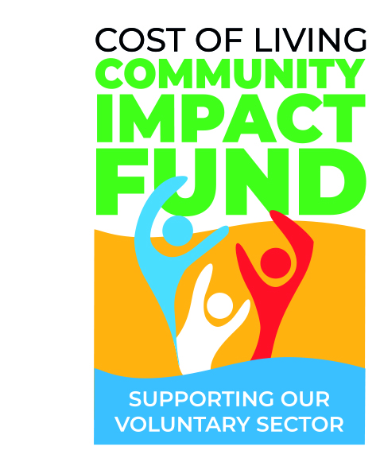

Cost of Living
Community Impact Fund
2023/2024
PREVIEW OF APPLICATION QUESTIONS
DRAFT

Before completing your online application, you can use this form to prepare your answers.
- Do not submit this form as your application.
- Applications must be completed online by clicking the ‘apply now’ button on the Cost of Living Community Impact Fund website.
- Please be advised, when completing the online application form, each page will refresh after 60 minutes in compliance with data protection.
If you have any questions about the Cost-of-Living Community Impact Fund, please contact the Officer below:
Contact Officer:
Name: Elliott Allen (Community Services Team Leader)
Email: CommunityGrants@dover.gov.uk

Question | Response
Please confirm your details
Organisation/Group Name
Name of main contact
Position/Role
Contact Address
Telephone
Email address
Please tell us about your project
What is the title of your project?
Where will your project take place?
When will your project start?
When will your project end?
Overview of your project?
How has the cost of living affected the residents you would like to support?
How will your project support residents struggling with the cost of living?
How many beneficiaries will your project have?
How will you measure your project achievements?
What will happen to your project if this application is not successful?
Does your project require any permissions? | (Evidence of permissions can be uploaded if required).
Please tell us your project costs
What are your total project costs? | £
(Row 1) Description of item/s
(Row 1) Cost | £
(Row 1) Is DDC funding this | Yes / No
(Row 1) If DDC isn't funding this item, how will it be secured? Is it secured?
The online form will provide multiple rows, for you to enter your costs.

Please provide information of any other funding streams that are funding any part of this project
Please confirm how much are you applying for, from the Community Impact Fund? (£100-£2,500)
Please tell us about your Management Committee
(Row 1) Name
(Row 1) Position/Role
(Row 1) Date Elected (to this role)
(Row 1) Preferred Contact details (either phone or email)
The online form will provide multiple rows, for you to enter your Management Committee

Please confirm your bank details
Name of Bank
Account Name
Account Number
Sort Code
Please provide details of at least 2 signatories for this bank account
(Row 1) Signatories
(Row 2) Signatories
Does your group have any other Bank accounts in its name?
If so what
What is the annual turnover of your organisation/group? | £
What are your core operational costs during one full year?: | £
What are your current restricted reserves? | £
What are your current unrestricted reserves? | £

END

