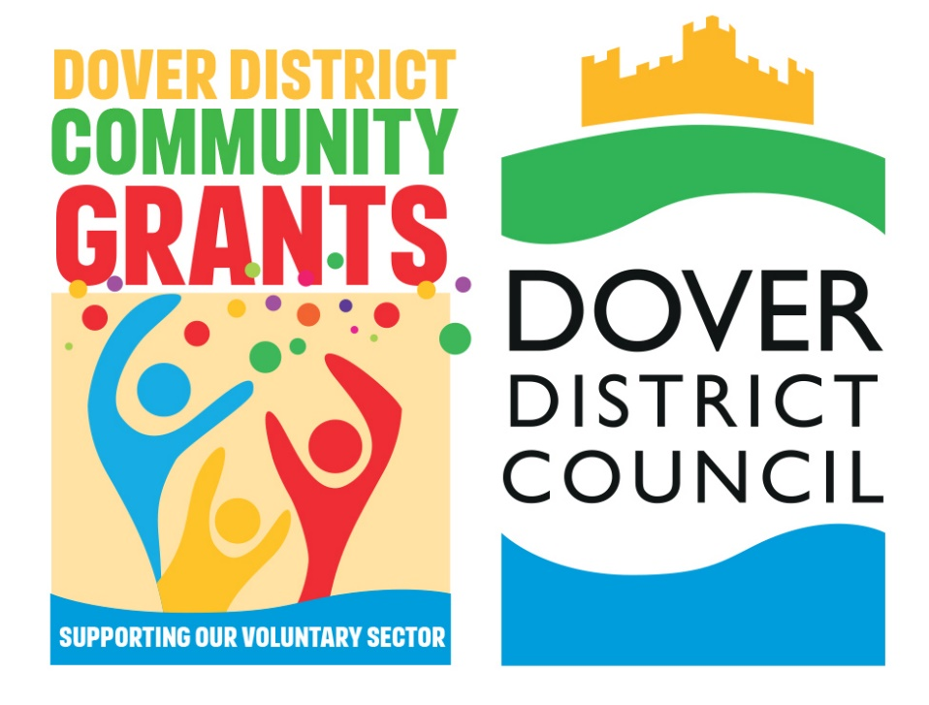

Community Grant Scheme
2025/2026
PREVIEW OF APPLICATION QUESTIONS
DRAFT

Before completing your online application, you can use this form to prepare your answers.
- Do not submit this form as your application.
- Applications must be completed online by clicking the ‘apply now’ button on the Community Grant Scheme webpage.
- Please be advised, when completing the online application form, each page will refresh after 60 minutes in compliance with data protection.
If you have any questions about the Community Grant Scheme, please contact the Officer below:
Contact Officer:
Name: Rebecca Dunroe (Community Development Officer)
Email: CommunityGrants@dover.gov.uk

Question | Response
Please confirm your details
Organisation/Group Name
Name of main contact
Position/Role
Contact Address
Telephone
Email address
Please tell us about your project
What is the title of your project?
Where will your project take place?
When will your project start?
When will your project end?
Overview of your project?
How many beneficiaries will your project have?
How does your project relate to Strategic Priority One - Improving our housing. | This question is required, if you feel your project does not suit this priority, please input n/a.
How does your project relate to Strategic Priority Two - Growing our economy. | This question is required, if you feel your project does not suit this priority, please input n/a.
How does your project relate to Strategic Priority Three - Protecting our environment. | This question is required, if you feel your project does not suit this priority, please input n/a.
How does your project relate to Strategic Priority Four - Supporting our communities. | This question is required, if you feel your project does not suit this priority, please input n/a.
How does your project relate to Strategic Priority Five - Modernising our Council. | This question is required, if you feel your project does not suit this priority, please input n/a.
How will you measure your project achievements?
What will happen to your project if this application is not successful?
Have you applied for a DDC grant before?
Is your monitoring complete?
Does your project require any permissions? | (Evidence of permissions can be uploaded if required).
Please tell us your project costs
What are your total project costs? | £
Please confirm how much are you applying for, from the Community Grants Scheme? (£100-£5000)
(Row 1) Description of item/s
(Row 1) Cost | £
(Row 1) Is DDC funding this | Yes / No
(Row 1) If DDC isn't funding this item, please confirm who is?
The online form will provide multiple rows, for you to enter your costs.

What local organisations have you approached for social value/in-kind support?
If you are successful and are offered less funding than requested, how would you finance the delivery of your project?
Please tell us about your Management Committee
(Row 1) Name
(Row 1) Position/Role
(Row 1) Date Elected (to this role)
(Row 1) Preferred Contact details (either phone or email)
The online form will provide 2 rows, for you to enter your 2 senior members

Please confirm your bank details
Name of Bank
Account Name
Account Number
Sort Code
Please provide details of at least 2 signatories for this bank account
(Row 1) Signatories
(Row 2) Signatories
Does your group have any other Bank accounts in its name?
If so what
What is the annual turnover of your organisation/group? | £
How big is your organisation? | Based within the Dover district, Kent County or nationally
What are your current unrestricted reserves? | £
If your organisation operates outside the Dover district, what reserves does your local branch/organisation hold? | £
Do you have a reserves policy?
If yes, what does this amount to?

END

