Please supply a map of the area that you wish to litter pick, you may wish to download one from [www.google.co.uk/maps](http://www.google.co.uk/maps)

If your event is taking place off the highway for example in a park, woodland or on a beach please provide full details of the location but you do not need to complete a map.

Using the map please indicate all areas that you intend to litter pick on. We would like you to mark the roads using the following system:

**Red road** 40mph+ or alternatively a low speed road but with a specific hazard that may cause drivers difficulty in controlling their vehicles if they come across workers in the highway (for example visibility, sharp bends).

**Amber road** Low speed road with specific hazards where the road workers have additional risks to consider to ensure safe working practice (for example visibility, banks, hedges)

**Green road** Low speed road with good visibility and no additional risk level to consider.

Please mark the outlying edges of your litter pick, or simply circle the area that you intend to litter pick in.

See worked example below

*Kent County Council have produced a risk assessment proforma in line with the New Roads and Street Works Act 1991 and the associated Red Book guidance (Chapter 8 Traffic Safety measures & signs for road works and temporary situations) to ensure not only compliance to the appropriate legislation and best practice, but fundamentally, volunteer safety.*

*Safety of people working on roads, including volunteers is paramount. KCC will not endorse, support or insure volunteer activities taking place on roads of 40 mph or above. This is the standard that KCC has set, although under no legal obligation to do so.*

*KCC's standard does not prevent residents wishing to litter pick (or other associated activities) in these areas, but they must be aware that their actions are undertaken at their own risk. At no time do we condone this. As hosts of the Kent Sensible Risk Management Campaign (led by the Health and Safety Executive), we are satisfied that the risk assessment and requirements of volunteers is appropriate and proportionate.*

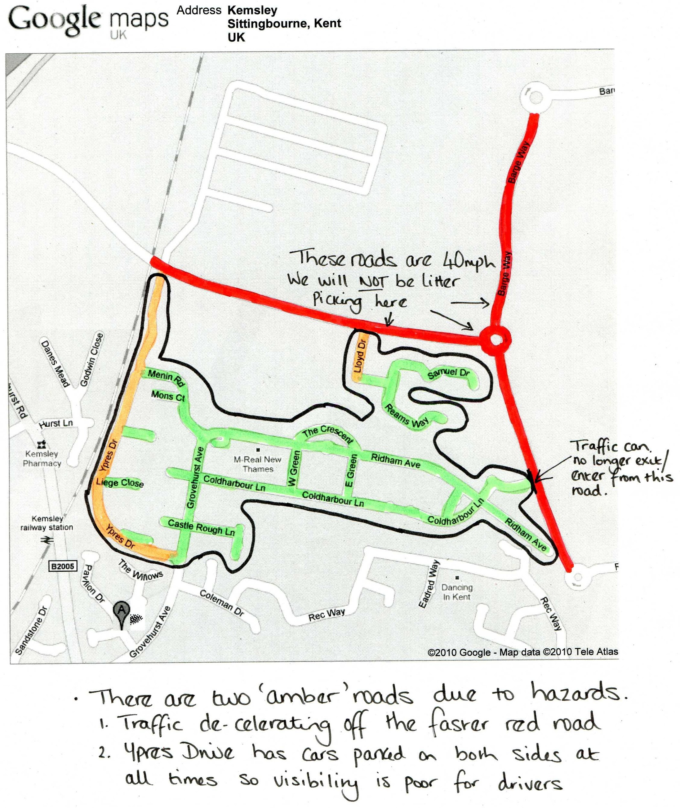

Below is an example of A257 leaving Wingham towards Sandwich, you can pick up to the signs BUT NOT beyond. So in this example you should not  litter pick on the right as you go up the hill because its not safe as there is no foot path. Its all about negating the risks not just of the litter pickers but also the traffic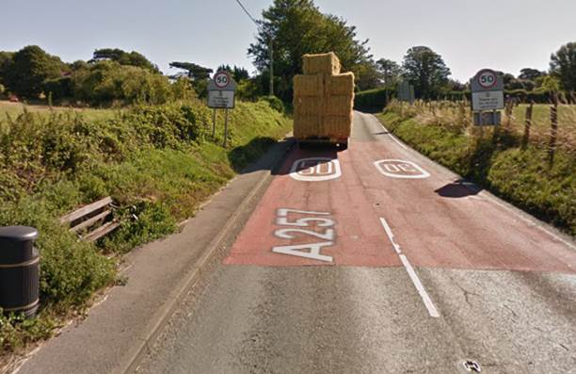e traffic

Risk assessment for volunteer litter clearance

|  |  |  |  |  |
| --- | --- | --- | --- | --- |
| **Hazard**  (A source of potential danger) | **Precautions**  To remove hazard, reduce risk | **Measures to reduce effect in the event of an accident** | **Management activity** | **Please initial to indicate understanding** |
| **Traffic** | * Mapped risk assessment to ensure road fits into Medium or Low risk category. * Use of reasonable safety measures. | Be aware of oncoming traffic and other hazards. Where possible, walk towards oncoming traffic. Do not litter pick along roads over 30mph.  Ensure use of Personal Protective Equipment.  Do not use mobile phones whilst on a highway. | One volunteer to act as ‘eyes and ears’ for traffic movements on behalf of the rest of the group. |  |
| **Lifting heavy objects** | * Do not move or lift objects unless necessary * Use mechanical aids, or handle with a number of people. Break up the load into smaller parcels. * Use good lifting technique. | Stop immediately if suffering any pain or discomfort.  Seek medical attention if ill effects persist. | If volunteers find large/heavy objects, make a note and report to the local council for removal after the event. |  |
| **Chemicals** | * Do not approach or remove containers which contain/contained chemicals | Seek medical attention if exposed to pesticides, insecticides or other chemicals − record any label details. | Contact the Environment Agency 0800 80 70 60. |  |
| **Cliffs, quarry faces, steep slopes** | * Avoid picking on or close to the edge of cliffs, quarries, steep slopes etc and below unstable cliffs and slopes * Take weather conditions and possible weather changes into account * Take account of tides | Seek medical treatment in the event of injury. | Instruct volunteers to stay away from these areas. |  |
| **Electric fences** | * Always assume electric fences are live * Avoid contact |  | Warn volunteers not to touch fences. |  |
| **Ground conditions** | * Wear strong boots with ankle support * Avoid dangerous areas and choose the safest possible route over difficult ground. | Seek medical attention for any serious cuts, bruises or strains. | Instruct volunteers to wear suitable footwear. |  |
| **Hedges, fences, walls, ditches** | * Take care climbing stiles particularly in wet weather * Avoid climbing walls, ditches and fences |  | Stay within the registered location. |  |
| **Water, marshes and bogs** | * Avoid banks, especially if they appear unstable. * Always work in pairs if close to water. | Shower and change to warm dry clothing if immersed. | Never allow children to work in these areas. Adults should be warned. |  |
| **Vehicles, bicycles, plant and machinery** | * Avoid close proximity if possible. * Stay off the highway. * Be alert to the potential presence of agricultural machinery. * Wear high visibility clothing if necessary. * Do not work on the roadside if the speed limit is 40mph or over. | Seek medical attention in the event of injury. | Be aware of the vehicles around you during the litter pick. Keep a look out. |  |
| **People and lone working** | * Beware of aggressive and difficult people. * Withdraw rather than face conflict. * Do not work out of sight of others in the group. * No school age children to be working on the highway * School age children working **off highway** to be fully supervised at **all** times. | Leader to have mobile phone.  Medical attention following any assault. | Keep together and stay off private property. |  |
| **Refuse, litter** | * Pick up only general litter. * Do not collect medical waste (e.g. needles etc) * Wear gloves and use a litter picker wherever practicable and available. | Seek medical attention for any cuts.  Keep anti−tetanus injections up to date. Any needles found should not be picked up and should be reported immediately to DDC on 01304 872428. At weekends, bank holidays, or any time that falls outside of weekday office hours (8:30am-6:00pm), any hazardous waste found should be reported immediately to the number above | Volunteers must wear the safety clothing provided. |  |
| **Tools and equipment** | * Team to be shown how to use equipment if appropriate. * Allow sufficient working area for the correct and safe use of the tool. * Use appropriate protection. | First aid training.  Have first aid kit available.  Obtain medical attention in the event of injury. | Volunteers must use the equipment provided and as instructed. |  |
| **Personal Protection Equipment** | * All attendees to wear hi-visibility tops (Class 3). |  | Volunteers must wear the safety clothing provided. |  |
| **Trees and shrubs** | * Be alert to the risks and keep a sharp look out for hazards. | Wear safety helmet in hazardous conditions. Obtain medical attention in the event of injury. | Be aware of low hanging branches and exposed tree/ shrub roots. |  |
| **Irritant and dangerous plants** | * Beware of dangerous plants & possible adverse reactions. * Wash thoroughly on completion of such operations. | Seek medical attention for unusual or suspicious symptoms after contact with vegetation. | Wear the gloves provided. |  |
| **Weather** | * Adjust work programmes to avoid extremes. * Cease work in inappropriate conditions. * Avoid over exertion in hot and cold extremes. * Dress for conditions and carry additional clothing. | Seek shelter. | In the event of extreme weather conditions the litter pick should be postponed / suspended. |  |
| **Individual capability** | * Check that individuals understand and are able to carry out voluntary work on site |  |  |  |
| **Other Hazard(s) not mentioned above − Leader to note** |  |  |  |  |

**Name of responsible person**  **Signature**

**Location of pick**  **Date**

**Contact telephone number**

* **This form is to be completed by the lead volunteer prior to the commencement of the clean up event and returned when collecting the equipment**
* **As the organiser of the event you will be responsible for informing volunteers of the identified risks and measures to reduce risk, prior to commencing your event.**